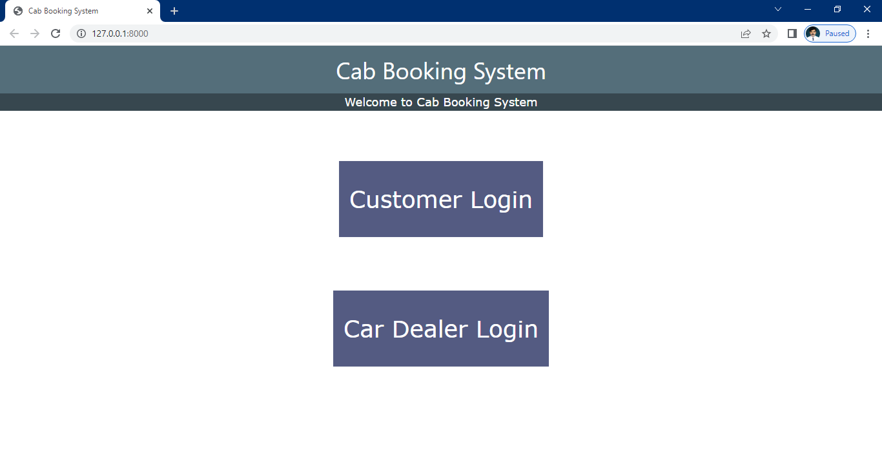

Dealer register

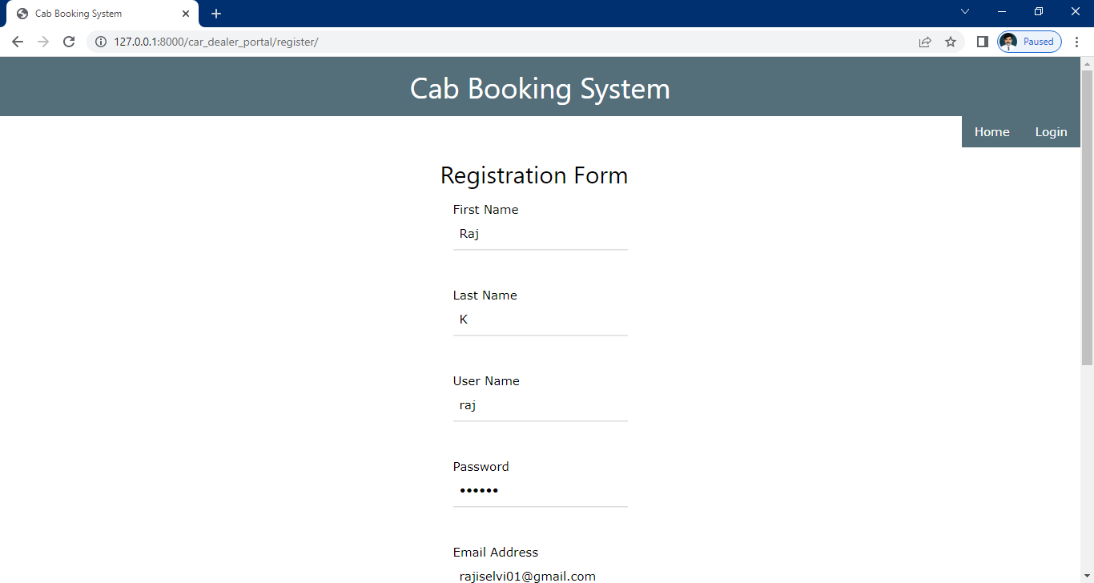

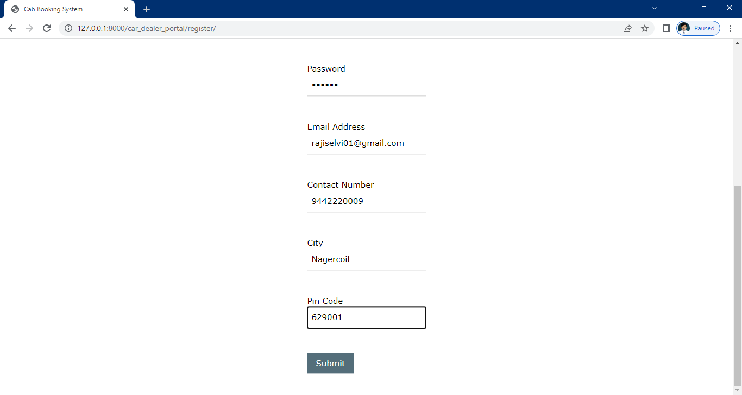

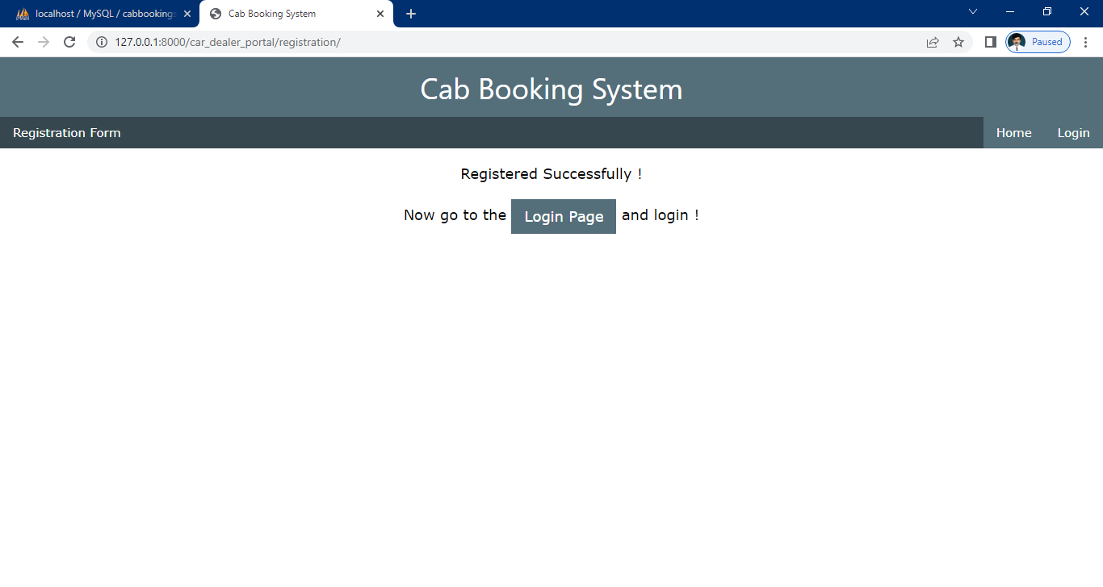

Dealer login

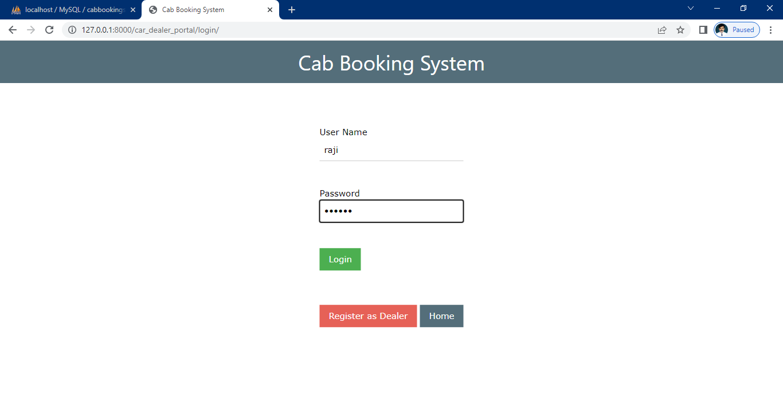

Dealer home

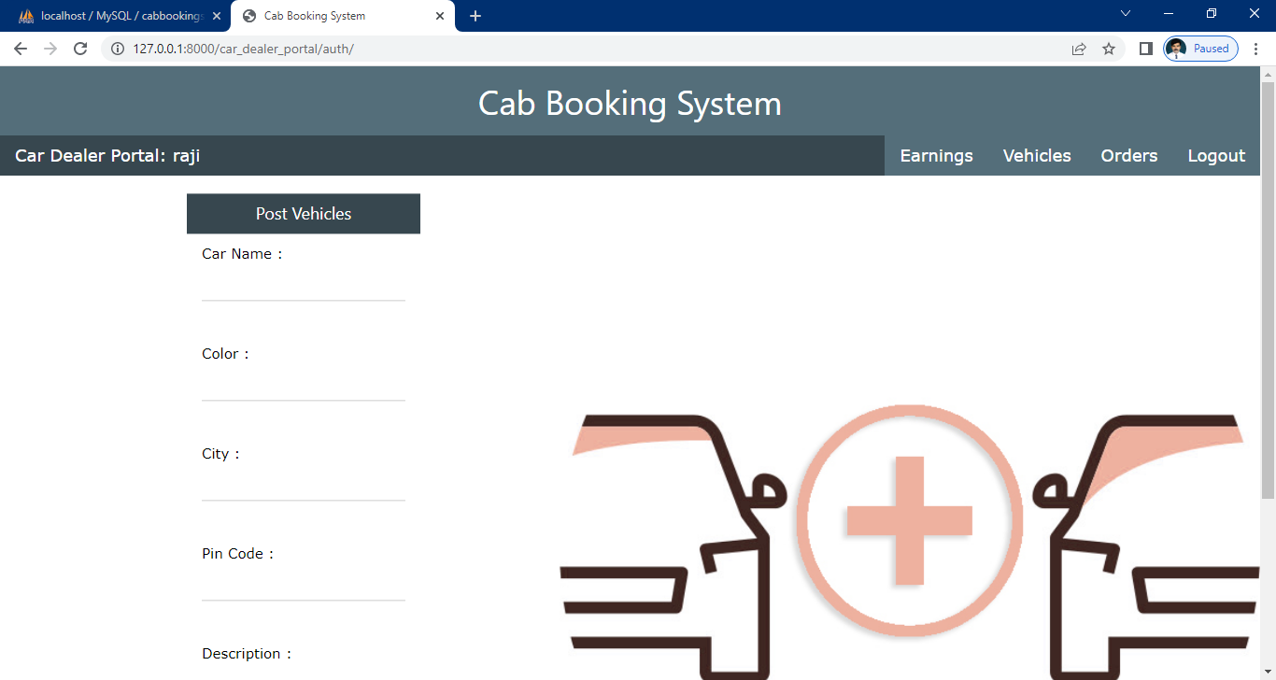

New car add

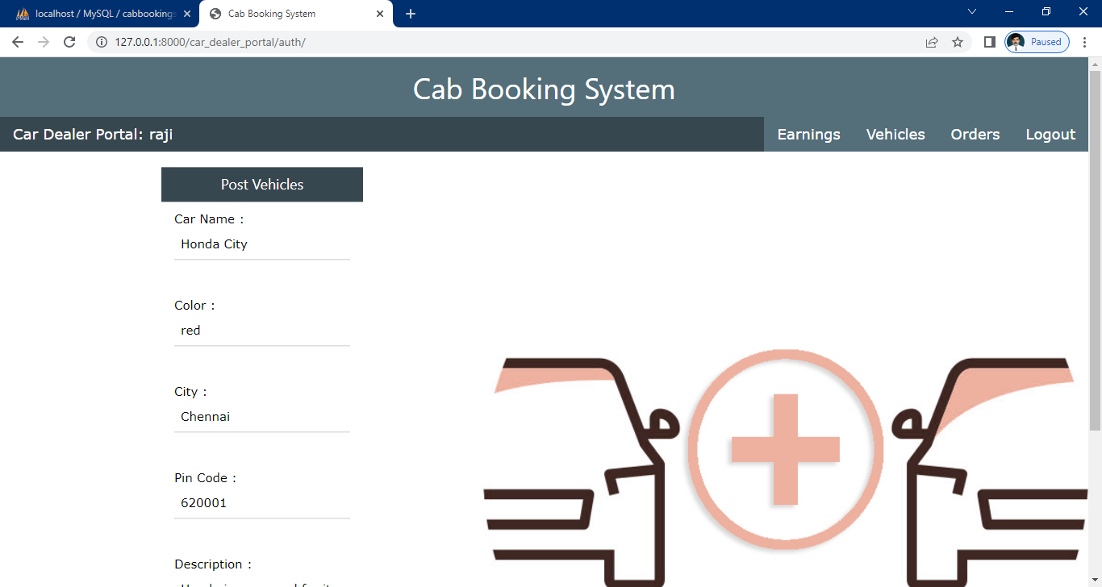

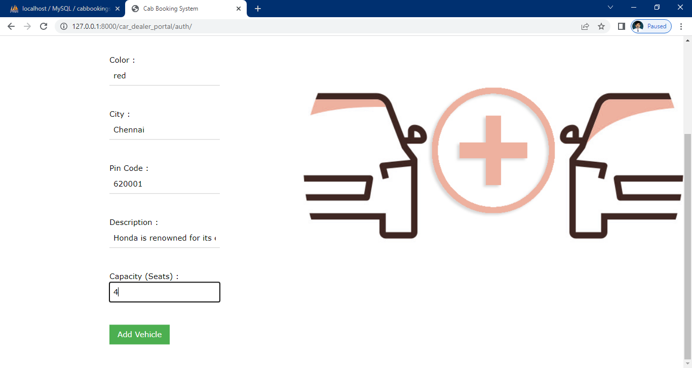

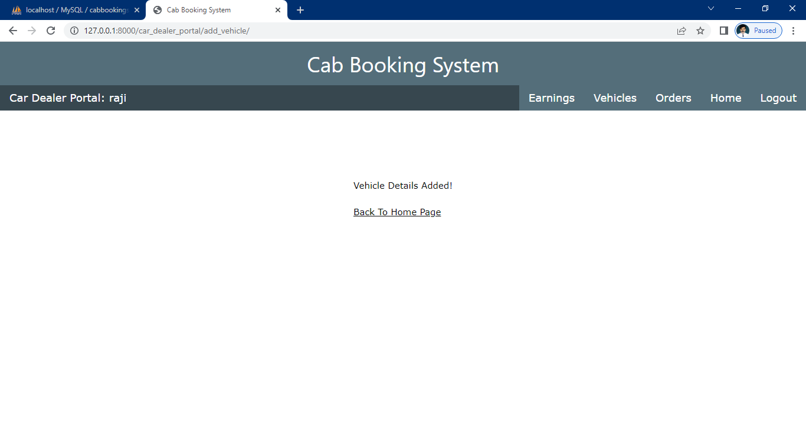

Display vehicles

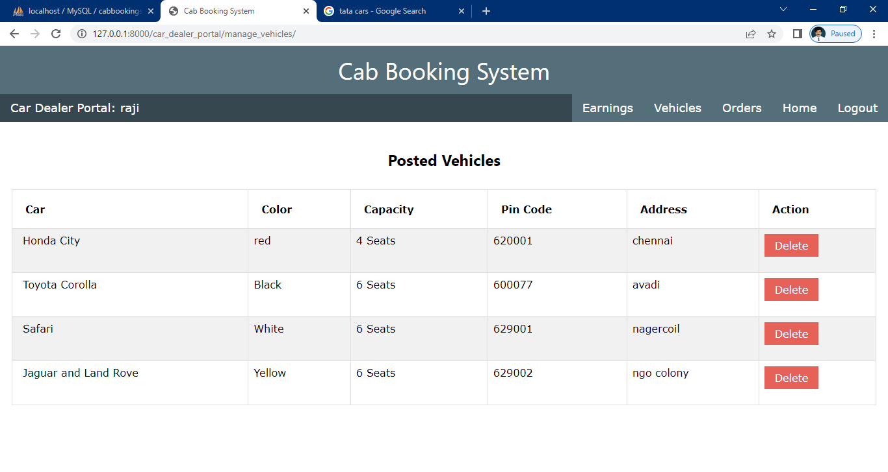

Earning income

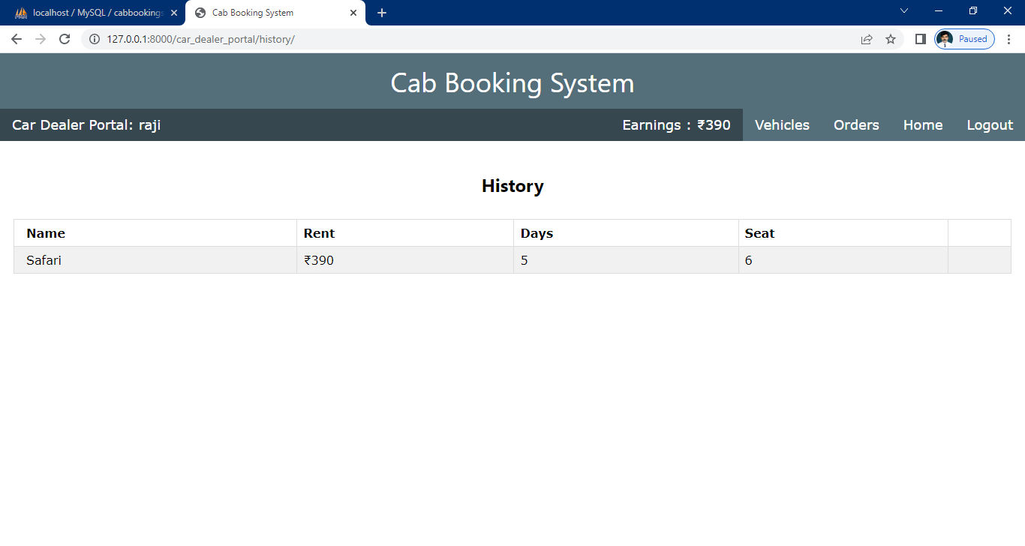

Cab booking history

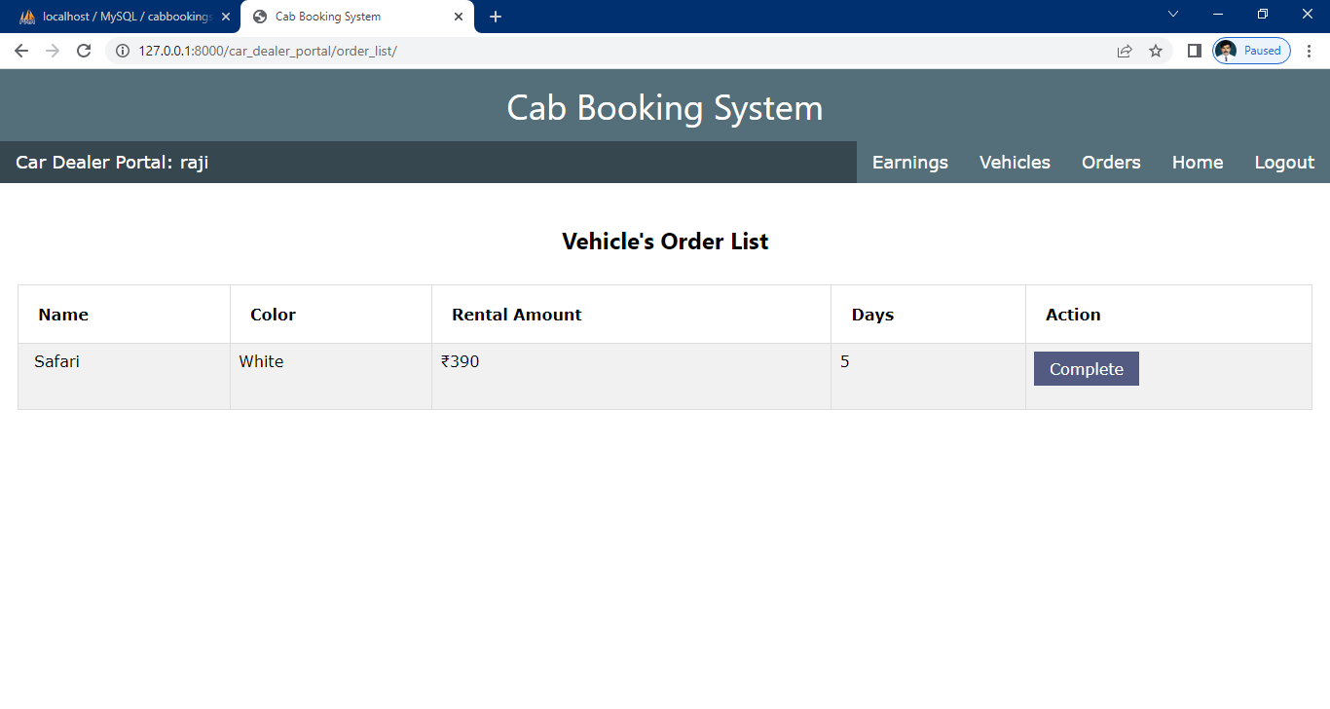

Customer register

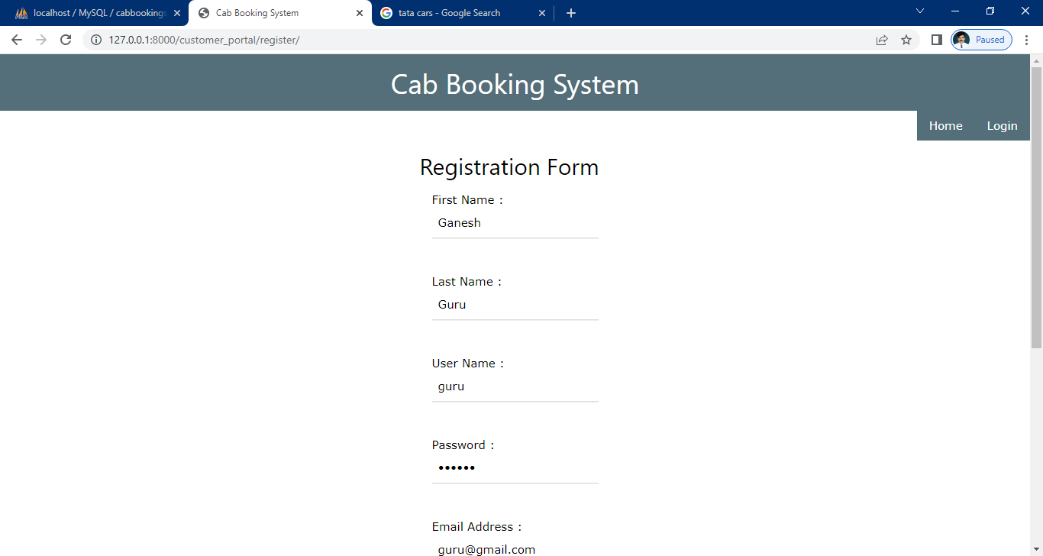

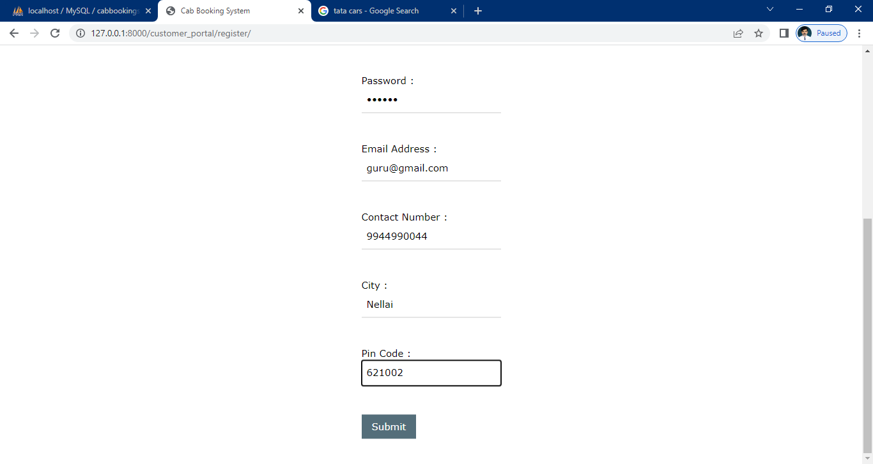

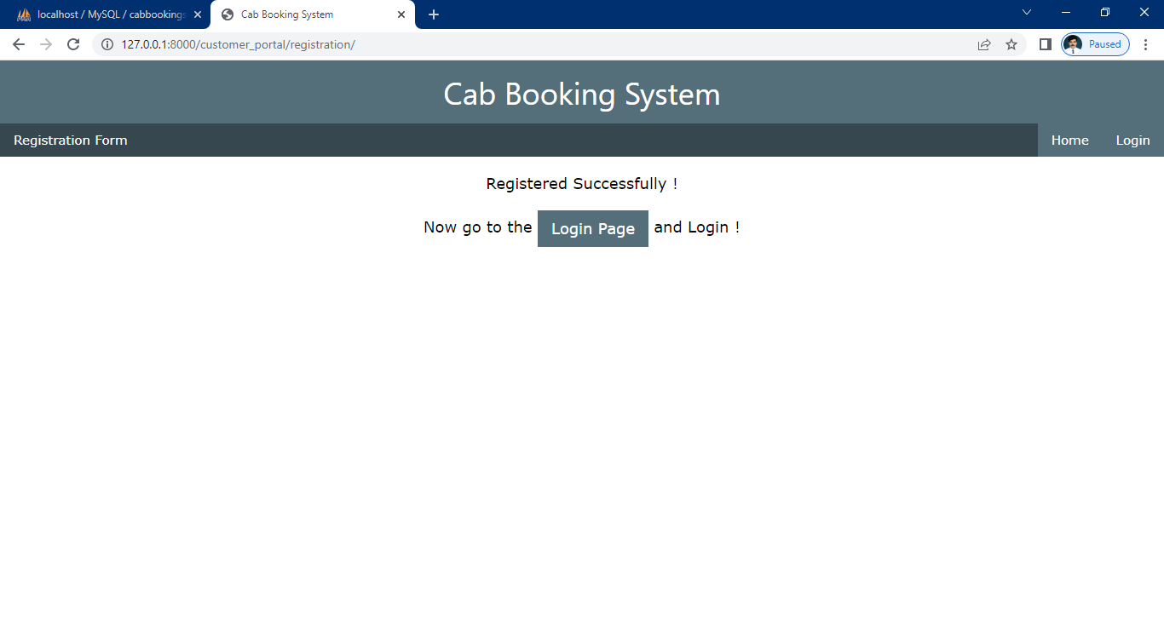

Customer login

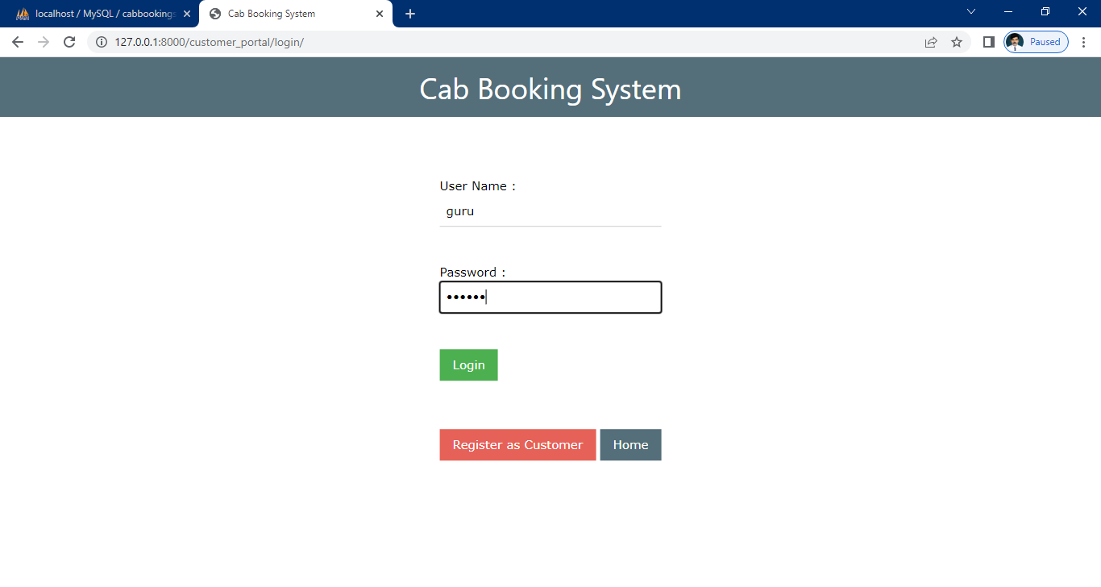

Customer home

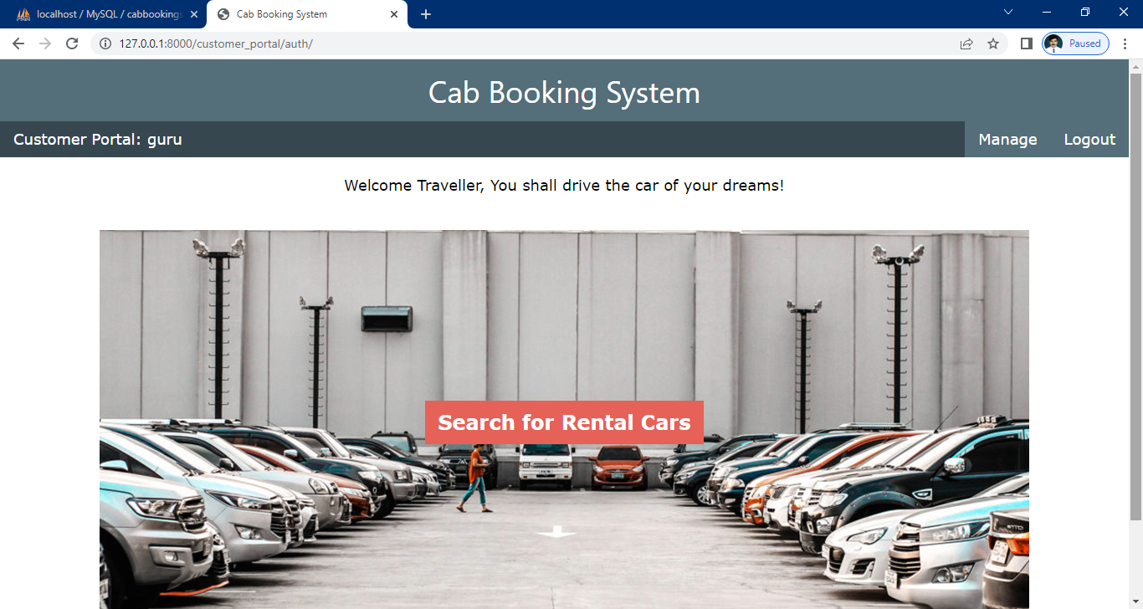

Search car

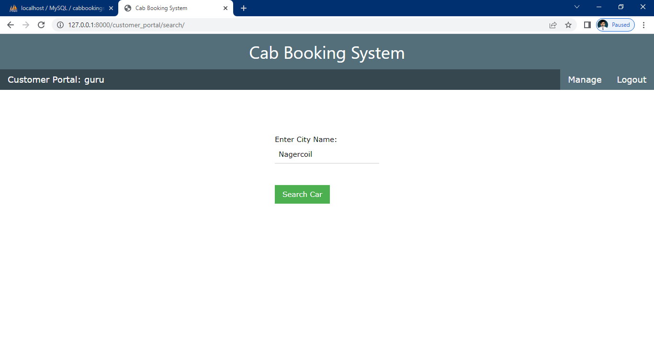

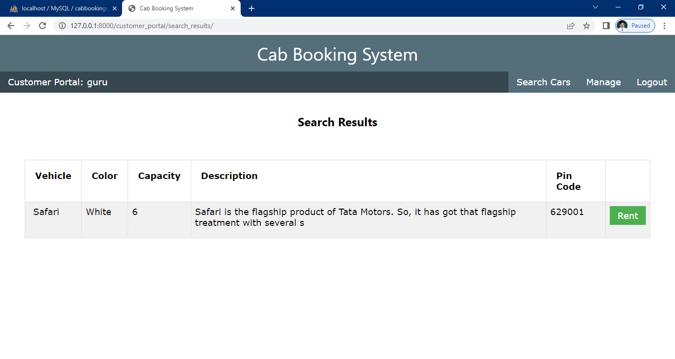

Cab booking

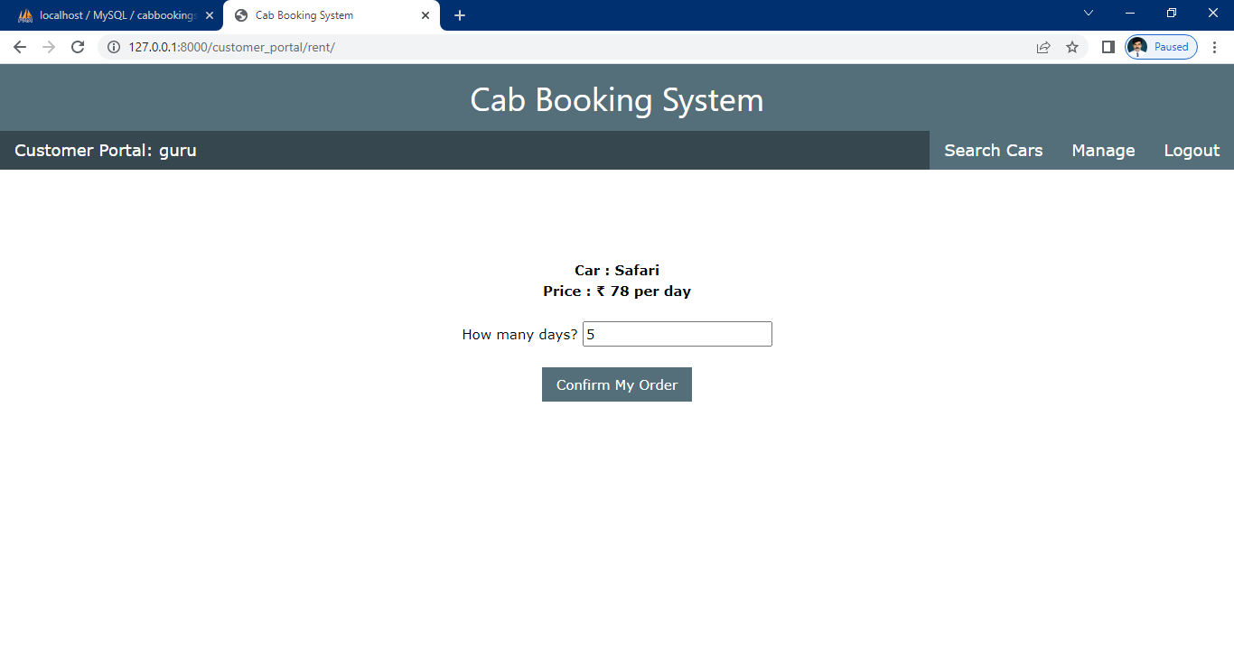

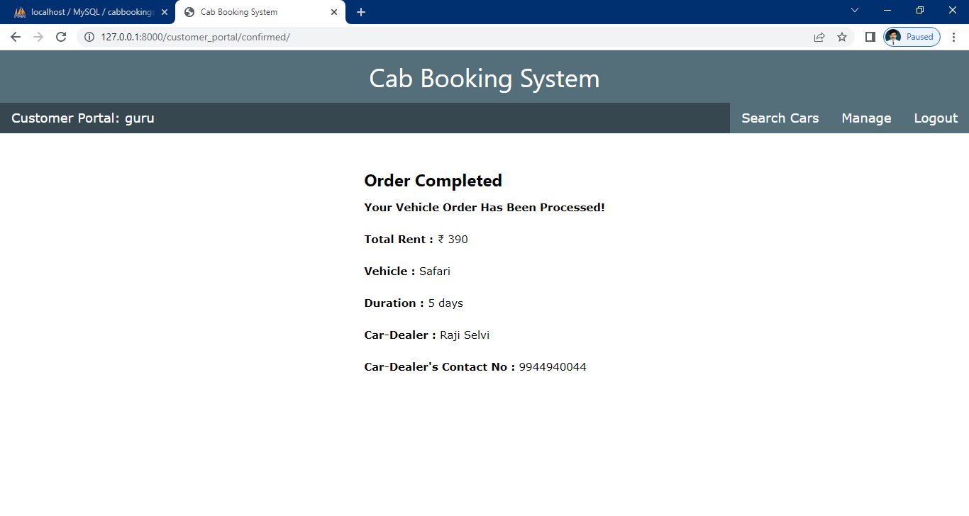

Booking reports

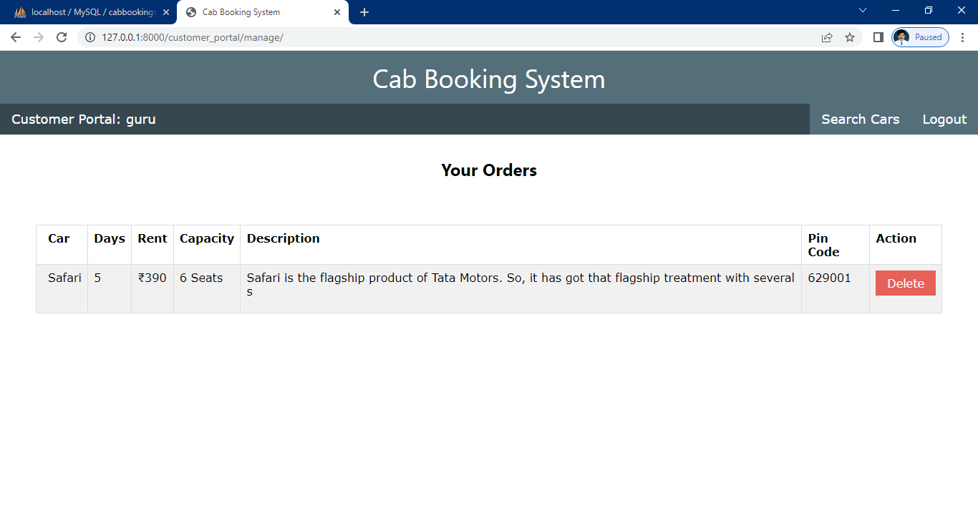

Source code

View.py

from django.shortcuts import render

from django.http import HttpResponse

from django.contrib.auth.models import User

from django.contrib.auth import authenticate

from django.contrib import auth

from car_dealer_portal.models import *

from customer_portal.models import *

from django.contrib.auth.decorators import login_required

from django.http import HttpResponseRedirect

# Create your views here.

def index(request):

if not request.user.is_authenticated:

return render(request, 'car_dealer/login.html')

else:

return render(request, 'car_dealer/home_page.html')

def login(request):

return render(request, 'car_dealer/login.html')

def auth_view(request):

if request.user.is_authenticated:

return render(request, 'car_dealer/home_page.html')

else:

username = request.POST['username']

password = request.POST['password']

user = authenticate(request, username=username, password=password)

try:

car_dealer = CarDealer.objects.get(car_dealer = user)

except:

car_dealer = None

if car_dealer is not None:

auth.login(request, user)

return render(request, 'car_dealer/home_page.html')

else:

return render(request, 'car_dealer/login_failed.html')

def logout_view(request):

auth.logout(request)

return render(request, 'car_dealer/login.html')

def register(request):

return render(request, 'car_dealer/register.html')

def registration(request):

username = request.POST['username']

password = request.POST['password']

mobile = request.POST['mobile']

firstname = request.POST['firstname']

lastname = request.POST['lastname']

email = request.POST['email']

city = request.POST['city']

city = city.lower()

pincode = request.POST['pincode']

try:

user = User.objects.create_user(username = username, password = password, email = email)

user.first_name = firstname

user.last_name = lastname

user.save()

except:

return render(request, 'car_dealer/registration_error.html')

try:

area = Area.objects.get(city = city, pincode = pincode)

except:

area = None

if area is not None:

car_dealer = CarDealer(car_dealer = user, mobile = mobile, area=area)

else:

area = Area(city = city, pincode = pincode)

area.save()

area = Area.objects.get(city = city, pincode = pincode)

car_dealer = CarDealer(car_dealer = user, mobile = mobile, area=area)

car_dealer.save()

return render(request, 'car_dealer/registered.html')

@login_required

def add_vehicle(request):

car_name = request.POST['car_name']

color = request.POST['color']

cd = CarDealer.objects.get(car_dealer=request.user)

city = request.POST['city']

city = city.lower()

pincode = request.POST['pincode']

description = request.POST['description']

capacity = request.POST['capacity']

try:

area = Area.objects.get(city = city, pincode = pincode)

except:

area = None

if area is not None:

car = Vehicles(car_name=car_name, color=color, dealer=cd, area = area, description = description, capacity=capacity)

else:

area = Area(city = city, pincode = pincode)

area.save()

area = Area.objects.get(city = city, pincode = pincode)

car = Vehicles(car_name=car_name, color=color, dealer=cd, area = area,description=description, capacity=capacity)

car.save()

return render(request, 'car_dealer/vehicle_added.html')

@login_required

def manage_vehicles(request):

username = request.user

user = User.objects.get(username = username)

car_dealer = CarDealer.objects.get(car_dealer = user)

vehicle_list = []

vehicles = Vehicles.objects.filter(dealer = car_dealer)

for v in vehicles:

vehicle_list.append(v)

return render(request, 'car_dealer/manage.html', {'vehicle_list':vehicle_list})

@login_required

def order_list(request):

username = request.user

user = User.objects.get(username = username)

car_dealer = CarDealer.objects.get(car_dealer = user)

orders = Orders.objects.filter(car_dealer = car_dealer)

order_list = []

for o in orders:

if o.is_complete == False:

order_list.append(o)

return render(request, 'car_dealer/order_list.html', {'order_list':order_list})

@login_required

def complete(request):

order_id = request.POST['id']

order = Orders.objects.get(id = order_id)

vehicle = order.vehicle

order.is_complete = True

order.save()

vehicle.is_available = True

vehicle.save()

return HttpResponseRedirect('/car_dealer_portal/order_list/')

@login_required

def history(request):

user = User.objects.get(username = request.user)

car_dealer = CarDealer.objects.get(car_dealer = user)

orders = Orders.objects.filter(car_dealer = car_dealer)

order_list = []

for o in orders:

order_list.append(o)

return render(request, 'car_dealer/history.html', {'wallet':car_dealer.wallet, 'order_list':order_list})

@login_required

def delete(request):

veh_id = request.POST['id']

vehicle = Vehicles.objects.get(id = veh_id)

vehicle.delete()

return HttpResponseRedirect('/car_dealer_portal/manage_vehicles/')

def index(request):

if not request.user.is_authenticated:

return render(request, 'customer/login.html')

else:

return render(request, 'customer/home_page.html')

def login(request):

return render(request, 'customer/login.html')

def auth_view(request):

if request.user.is_authenticated:

return render(request, 'customer/home_page.html')

else:

username = request.POST['username']

password = request.POST['password']

user = authenticate(request, username=username, password=password)

try:

customer = Customer.objects.get(user = user)

except:

customer = None

if customer is not None:

auth.login(request, user)

return render(request, 'customer/home_page.html')

else:

return render(request, 'customer/login_failed.html')

def logout_view(request):

auth.logout(request)

return render(request, 'customer/login.html')

def register(request):

return render(request, 'customer/register.html')

def registration(request):

username = request.POST['username']

password = request.POST['password']

mobile = request.POST['mobile']

firstname = request.POST['firstname']

lastname = request.POST['lastname']

email = request.POST['email']

city = request.POST['city']

city = city.lower()

pincode = request.POST['pincode']

try:

user = User.objects.create_user(username = username, password = password, email = email)

user.first_name = firstname

user.last_name = lastname

user.save()

except:

return render(request, 'customer/registration_error.html')

try:

area = Area.objects.get(city = city, pincode = pincode)

except:

area = None

if area is not None:

customer = Customer(user = user, mobile = mobile, area = area)

else:

area = Area(city = city, pincode = pincode)

area.save()

area = Area.objects.get(city = city, pincode = pincode)

customer = Customer(user = user, mobile = mobile, area = area)

customer.save()

return render(request, 'customer/registered.html')

@login_required

def search(request):

return render(request, 'customer/search.html')

@login_required

def search_results(request):

city = request.POST['city']

city = city.lower()

vehicles_list = []

area = Area.objects.filter(city = city)

for a in area:

vehicles = Vehicles.objects.filter(area = a)

for car in vehicles:

if car.is_available == True:

vehicle_dictionary = {'name':car.car_name, 'color':car.color, 'id':car.id, 'pincode':car.area.pincode, 'capacity':car.capacity, 'description':car.description}

vehicles_list.append(vehicle_dictionary)

request.session['vehicles_list'] = vehicles_list

return render(request, 'customer/search_results.html')

@login_required

def rent_vehicle(request):

id = request.POST['id']

vehicle = Vehicles.objects.get(id = id)

cost_per_day = int(vehicle.capacity)*13

return render(request, 'customer/confirmation.html', {'vehicle':vehicle, 'cost_per_day':cost_per_day})

@login_required

def confirm(request):

vehicle_id = request.POST['id']

username = request.user

user = User.objects.get(username = username)

days = request.POST['days']

vehicle = Vehicles.objects.get(id = vehicle_id)

if vehicle.is_available:

car_dealer = vehicle.dealer

rent = (int(vehicle.capacity))*13*(int(days))

car_dealer.wallet += rent

car_dealer.save()

try:

order = Orders(vehicle = vehicle, car_dealer = car_dealer, user = user, rent=rent, days=days)

order.save()

except:

order = Orders.objects.get(vehicle = vehicle, car_dealer = car_dealer, user = user, rent=rent, days=days)

vehicle.is_available = False

vehicle.save()

return render(request, 'customer/confirmed.html', {'order':order})

else:

return render(request, 'customer/order_failed.html')

@login_required

def manage(request):

order_list = []

user = User.objects.get(username = request.user)

try:

orders = Orders.objects.filter(user = user)

except:

orders = None

if orders is not None:

for o in orders:

if o.is_complete == False:

order_dictionary = {'id':o.id,'rent':o.rent, 'vehicle':o.vehicle, 'days':o.days, 'car_dealer':o.car_dealer}

order_list.append(order_dictionary)

return render(request, 'customer/manage.html', {'od':order_list})

@login_required

def update_order(request):

order_id = request.POST['id']

order = Orders.objects.get(id = order_id)

vehicle = order.vehicle

vehicle.is_available = True

vehicle.save()

car_dealer = order.car_dealer

car_dealer.wallet -= int(order.rent)

car_dealer.save()

order.delete()

cost_per_day = int(vehicle.capacity)*13

return render(request, 'customer/confirmation.html', {'vehicle':vehicle}, {'cost_per_day':cost_per_day})

@login_required

def delete_order(request):

order_id = request.POST['id']

order = Orders.objects.get(id = order_id)

car_dealer = order.car_dealer

car_dealer.wallet -= int(order.rent)

car_dealer.save()

vehicle = order.vehicle

vehicle.is_available = True

vehicle.save()

order.delete()

return HttpResponseRedirect('/customer_portal/manage/')

models.py

from django.db import models

from django.db import models

from django.core.validators import *

from django.contrib.auth.models import User

# Create your models here.

class Area(models.Model):

pincode = models.CharField(validators = [MinLengthValidator(6), MaxLengthValidator(6)],max_length = 6,unique=True)

city = models.CharField(max_length = 20)

class CarDealer(models.Model):

car_dealer = models.OneToOneField(User, on_delete=models.CASCADE)

mobile = models.CharField(validators = [MinLengthValidator(10), MaxLengthValidator(13)], max_length = 13)

area = models.OneToOneField(Area, on_delete=models.PROTECT)

wallet = models.IntegerField(default = 0)

class Vehicles(models.Model):

car_name = models.CharField(max_length = 20)

color = models.CharField(max_length = 10)

dealer = models.ForeignKey(CarDealer, on_delete = models.PROTECT)

area = models.ForeignKey(Area, on_delete=models.SET_NULL, null = True)

capacity = models.CharField(max_length = 2)

is_available = models.BooleanField(default = True)

description = models.CharField(max_length = 100)

class DriverDetails(models.Model):

did = models.IntegerField(default = 0)

dname = models.CharField(max_length=100)

mobile = models.CharField(validators = [MinLengthValidator(10), MaxLengthValidator(13)], max_length = 13)

car_name = models.CharField(max_length = 20)

class Customer(models.Model):

user = models.OneToOneField(User, on_delete=models.CASCADE)

mobile = models.CharField(validators = [MinLengthValidator(10), MaxLengthValidator(13)], max_length = 13)

area = models.ForeignKey(Area, on_delete=models.PROTECT)

class Orders(models.Model):

user = models.ForeignKey(User, on_delete=models.PROTECT)

car_dealer = models.ForeignKey(CarDealer, on_delete=models.PROTECT)

rent = models.CharField(max_length=8)

vehicle = models.ForeignKey(Vehicles, on_delete=models.PROTECT)

days = models.CharField(max_length = 3)

is_complete = models.BooleanField(default = False)